A Simple Explanation of Energy Storage
In Australia, the federal government proposed at one time that a renewable energy station must guarantee supply. Suppose as a builder of such a station you must not only account for the energy you generate but also have facilities that will give the same output when the wind decreases. As an example, suppose the SnowTown Wind Farm must do this. This station is highly efficient, supplying on average 35% of its rated capacity, but for the purposes of this exercise the assumption is made that it will be an average one. On the eastern grid of Australia, the average for wind energy as a whole is 28%. This means since this wind farm has a capacity of 99 MW (Stage 1), to fulfil this a constant 27.7 MW would be required (99 × 0.28).
To be prudent, before committing to this requirement, a search of the data on wind performance in the area to find wind droughts would be done. See figure 1. It is found that at 09:00 on 5 June 2020 the wind stopped at this station. In fact, if you look closely, it started using electricity since the turbines must be kept moving. The drought persisted for 30 hours until 15:00 on 6 June 2020. To keep dispatching energy at the agreed rate of 27.7 MW 831 MWh of storage is needed. (30 × 27.7)
Figure 1 Wind Drought
A few years ago, here in Australia the State of South Australia had a major blackout. To much fanfare the USA company Tesla proposed to build the largest grid scale battery of the time. This was subsequently done and has become known as the Hornsdale Reserve. With expansion it now has a capacity of 193.5MWh. The cost has been $172 million. To keep this single 99 MW power station for filling its requirement 4.3 of these would be needed. (831 ÷ 193.5 = 4.3) So, if it is possible to build a battery of sufficient size it will cost $740 million. (172 × 4.3 = 740) Wind turbine cost for 99 MW is $198 million. (99 × 2 = 198) So, the overall cost is $938 million (740 + 198 = 938) for the equivalent of a 30 MW gas powered electricity generator.
A costing shows the cost of such a generator, the General Electric LM6000. A single unit with an output of 47 MW costs $52.8 million. (938 ÷ 52.8 = 17.8) That is 18 times less!
The message is that there is no viable way lithium battery storage can present a cost-effective stabilisation of wind energy.
There are those who would say that by this article using one particular station the data have been cherry picked. No, not at all. The period in the chart above, figure 1, is typical of all wind stations on the Australian eastern grid at the time. Reality shows that wind patterns are very large and if you examine the eastern grid of Australia this is confirmed.
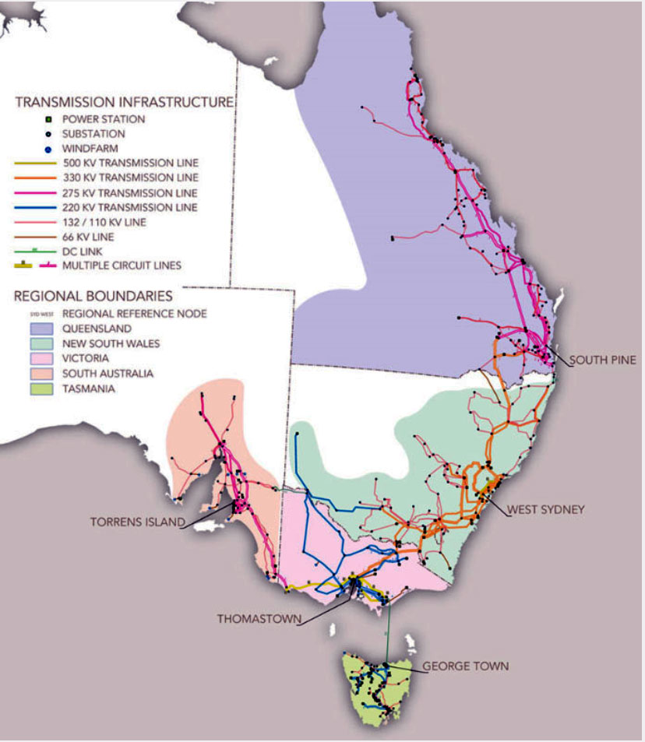
Figure 2 https://arenalive.azureedge.net/assets/2020/02/NEM_map1.jpg
This is the Australian eastern grid (figure 2). There are wind power stations in the north of Queensland down to Tasmania and across to South Australia. For those readers from other parts of the world, Australia is as big as the USA. This grid has an area of about 4,000,000 km² and there is little influence by area on the output of the wind stations.
Solar, for instance the Wemen which is 98 MW, does not have as long droughts, but it produces nothing every day for about 14 hours, and it does have variation. For instance, on 5th of June, during the time period above, the farm reaches a maximum of 30 MW then had no output for 14 hours until 6 June on which day it peaked at 60 MW. If calculated the expectation is there will be remarkably comparable results.
Note: all money amounts are AUD in this article.
Postscript: The chart in this article is from https://www.spasmodicenergy.com/Pages/Home.aspx. There you will find several different charts. Behind them there is a database of hourly data for the past 11 years. They have been produced for those who want to author articles about these matters. So, anyone is welcome to use them. Please let me know if you do.

